Name: ________________________

Class: ____

**BÀI LUYỆN TẬP TIẾNG ANH KHỐI 2**

**Năm học 2019 - 2020**

**Unit 8: Where’s Grandma? - Grammar**

**I. Look, read and match**.

1. How are you? • • She’s in the living room.

2. Where are Mom and Dad? • • Grandpa and Grandma in the kitchen.

3. Where’s Billy? • • I’m fine, thank you.

4. Where are Grandpa and Grandma?• • He’s in the bedroom.

5. Where’s Rosy? • • They’re in the dining room.

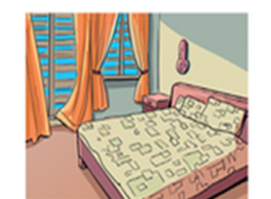**II. Look and write the answers**.

1. Where’s Billy? 2. Where are Mom and Dad?

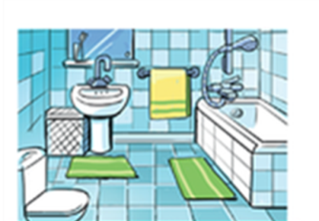 He’s in the bedroom. They’re in the ………………

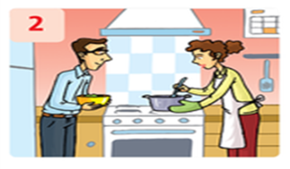

3. Where’s Rosy? 4. Are they in the living room?

She’s in …………………. No, ……………………….

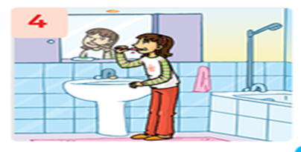

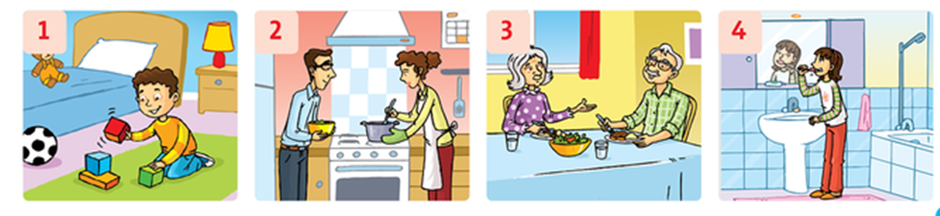

5. Where are Grandma and Grandpa? 6. Is she in the bedroom?

They’re ………………………… No, ………………….

**III. Look,** **choose and write.**

Where’s Where’re He’s She’s They’re

1. ___________ Rosy? ________ in the living room.

2.___________ Mom and Dad? __________ in the kitchen.

3. _____________ Grandma and Grandpa?_______________ in the diningroom.

4. ___________ Tim? ________________ in the bedroom.

Địa chỉ email của cô Thủy (2/1, 2/2): [wushimizu@gmail.com](mailto:wushimizu@gmail.com)

Địa chỉ email của cô Thơ (2/3, 2/4): [phantho8315@gmail.com](mailto:phantho8315@gmail.com)